Physics 3A/3B

ELECTRICITY AND MAGNETISM

TEST

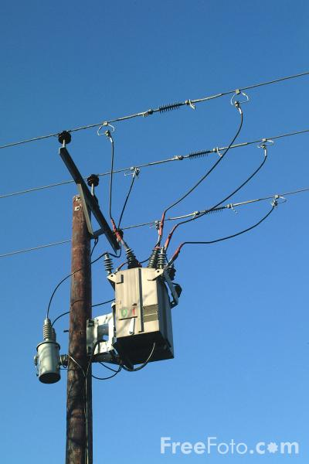

Time allowed: 70 min

To achieve full marks, clear, logical
working and diagrams MUST be shown.

Answers should be evaluated with an
appropriate number of significant figures.

Section A 7 Questions 22 marks
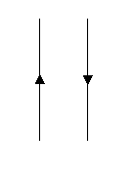
Question 1 ( 2 marks )

Two current carrying wires are set up as shown.
- Draw a clear diagram to indicate the field around one such wire.
(1 mark)

- What will happen to the wires when direct current flows in each wire as shown? (No explanation required.) (1 mark)

Question 2 ( 3 marks )

Paul had two bar magnets, one of which was half the strength of the other. He placed them a small distance apart, with the north pole of one facing the north pole of the other, covered them and sprinkled iron filings over them. Using magnetic flux lines sketch the pattern of the field observed.

Question 3 ( 3 marks )

A 150 m span of transmission cable running in an east- west direction is carrying a DC current of 5 A flowing towards the east. The cable is located in an area where the horizontal component of the earth’s magnetic field is 2.50 x 10⁻⁵ T. What is the magnitude and direction of the force experienced by the cable due to this current?

Question 4 ( 4 marks )

Imagine you are driving East in a truck where the vertical component of the Earth’s magnetic field is 5.00 x 10⁻⁵ T upwards. If the axle of the truck is 2.45 m long, and the truck is travelling at 90.0 kmh⁻¹ calculate the emf generated in the axle and state the end to which the electrons will migrate?

Question 5 ( 4 marks )

From Q 4, which hemisphere are you driving the truck in? Carefully explain your reasoning.

Question 6 ( 3 marks )

For the arrangement shown state the direction of any currents produced as the magnet is moved into the coil. Answer as Towards A or Towards B
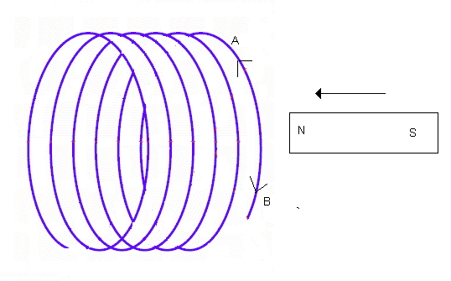

Question 7 ( 3 marks )

A coil has 400 turns with each of the coils having an area of 15.0 cm². The coil is placed in a magnetic field of flux density 0.800 T. What emf will be induced in the coil if the direction of the magnetic field is reversed in 2.45 s?

Section B 3 Questions 28 marks
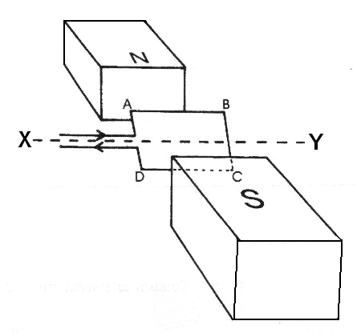

Question 1 ( 9 marks )

The coil ABCD, which is free to rotate about the axis XY, is
placed in a magnetic field of 9.08 mT. The coil consists of
25 turns and a current of 2.20 A is passing through it.
The coil is rectangular, with AB = 55.0 mm and
BC = 35.0 mm.

- Calculate the maximum torque on the motor. (3 marks)

- In which direction, clockwise or anticlockwise will the coil turn? ( 1 mark )

- Give two ways in which the torque could be increased. (2 marks)

- As constructed the coil will not rotate past the vertical position. Name and describe the structure which must be included in the design to allow the coil to rotate through 360º.

( 3 marks )
Question 2 ( 8 marks)

A transformer is being tested by a group of students. The primary coil is connected to a battery and a switch. The switch is closed allowing current to flow to the primary coil. The ammeter connected to the secondary coil initially deflects to the right then returns to its normal position.
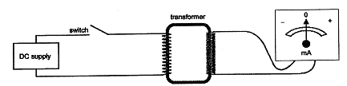

- A student watching the test states “something is wrong, transformers only work on AC, and there should be no current reading”.

Carefully explain the observations so as to respond to this statement.

(3 marks)
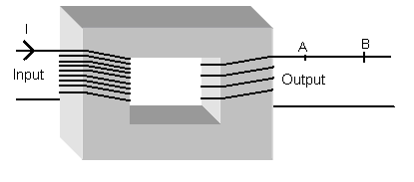
- Using this enlarged image and for the given current direction, will the momentary current flow in the secondary circuit from A to B or B to A?
(2 marks)

- Asuming the primary coil has 300 turns and the secondary coil 50 turns .
Which statement about the transformer is correct? (Circle letter)

A. Output current will larger than the input current
B. Output current will be smaller than the input current.
C. Output current will be equal to the input current.
(1 mark)

- If the primary coil is connected to a 240 V AC voltage supply, what will be the output voltage of this transformer?

(2 marks)

Question 3 ( 5 marks )

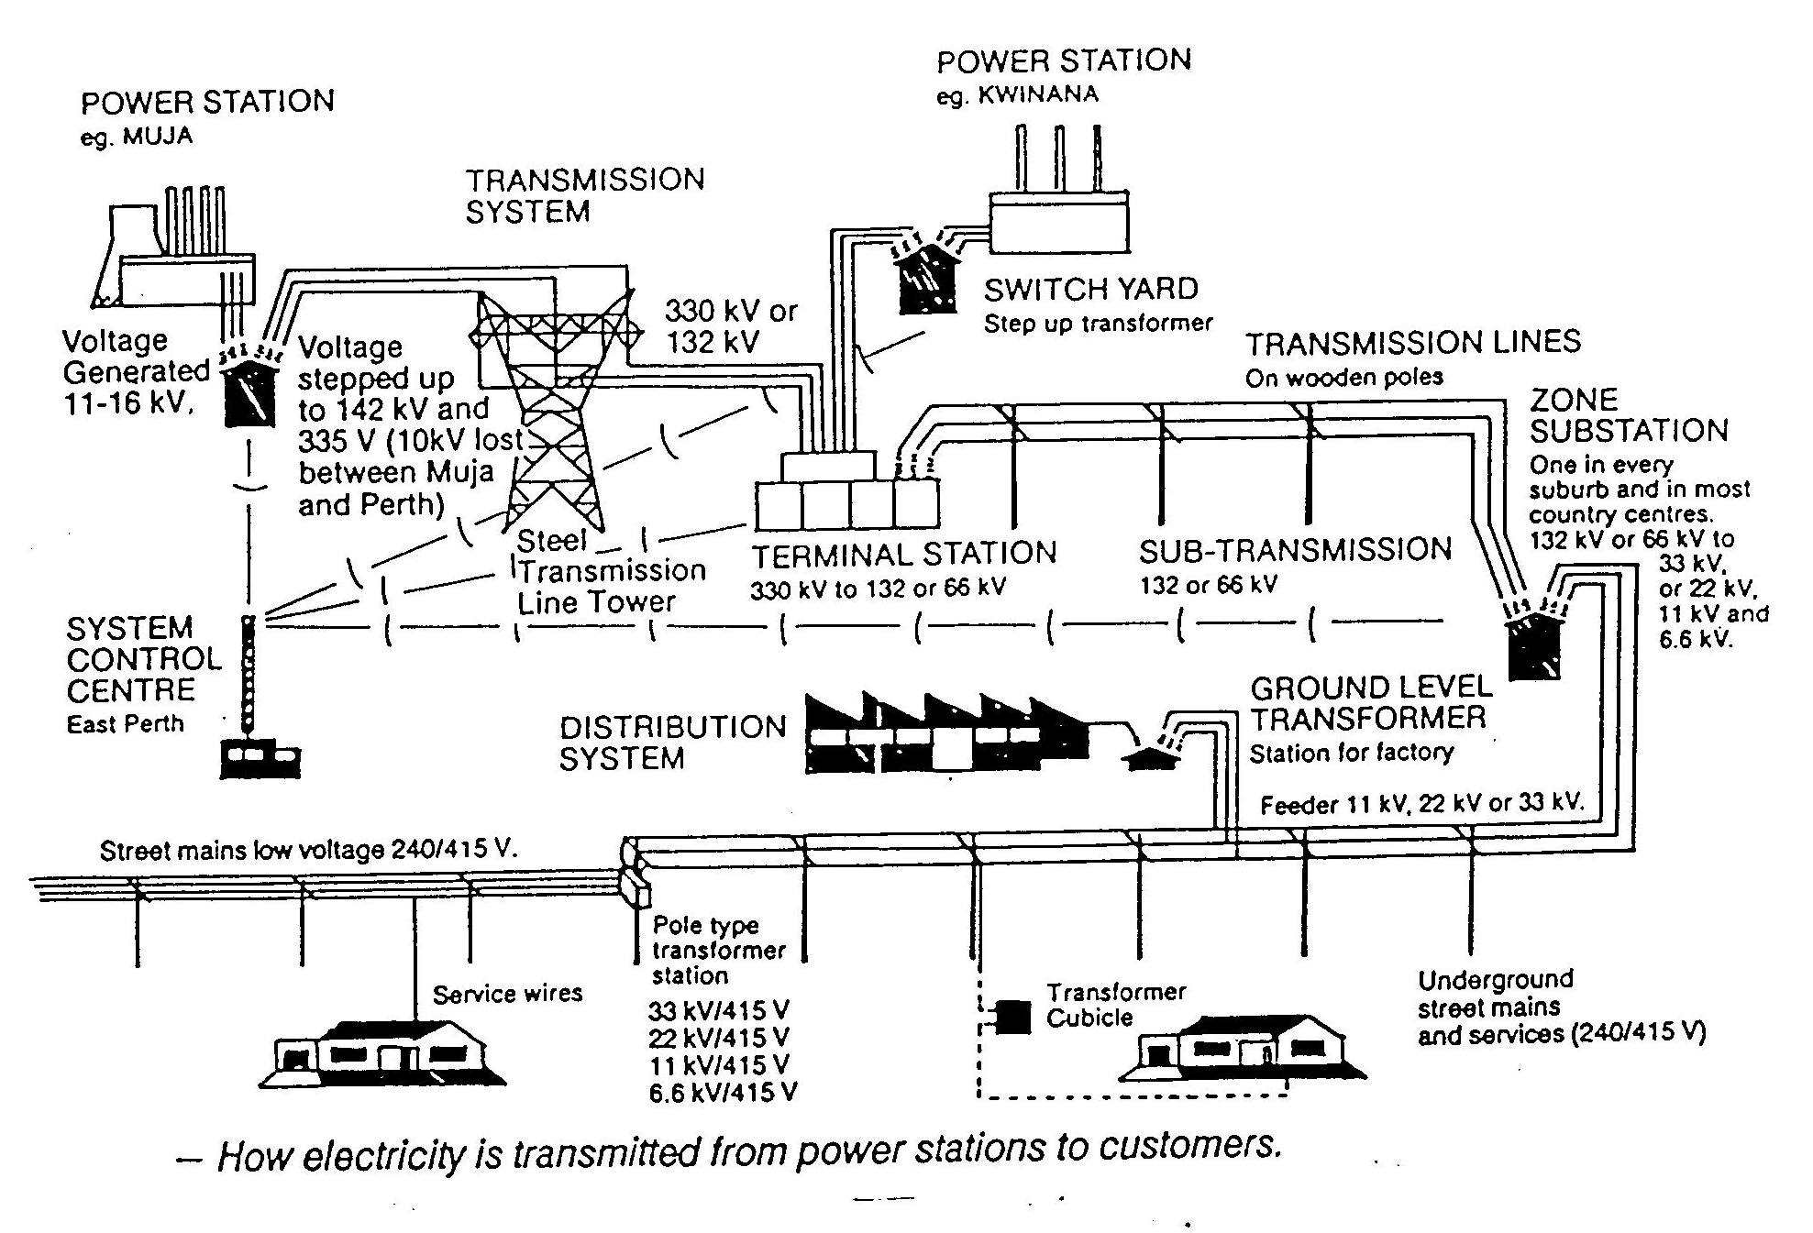
The diagram below shows the power transmission grid for the Perth region. The power is generated at a voltage of 11-16 kV, transmitted at 132 or 330 kV and supplied to houses and industry.

- What is the main reason that power is transmitted at high voltages?

( 1 mark )

- The demand for power in Perth can reach 1800 MW during peak loadings. Given that the resistance of the power lines from Muja to Perth, a distance of around 250 km, is 5 ohm, calculate the percentage power loss assuming it is transmitted at 330 kV?

(4 marks)

Question 4 ( 6 marks )

A coil is rotated in a magnetic field as shown. A graph of the voltage ( emf ) generated is also shown
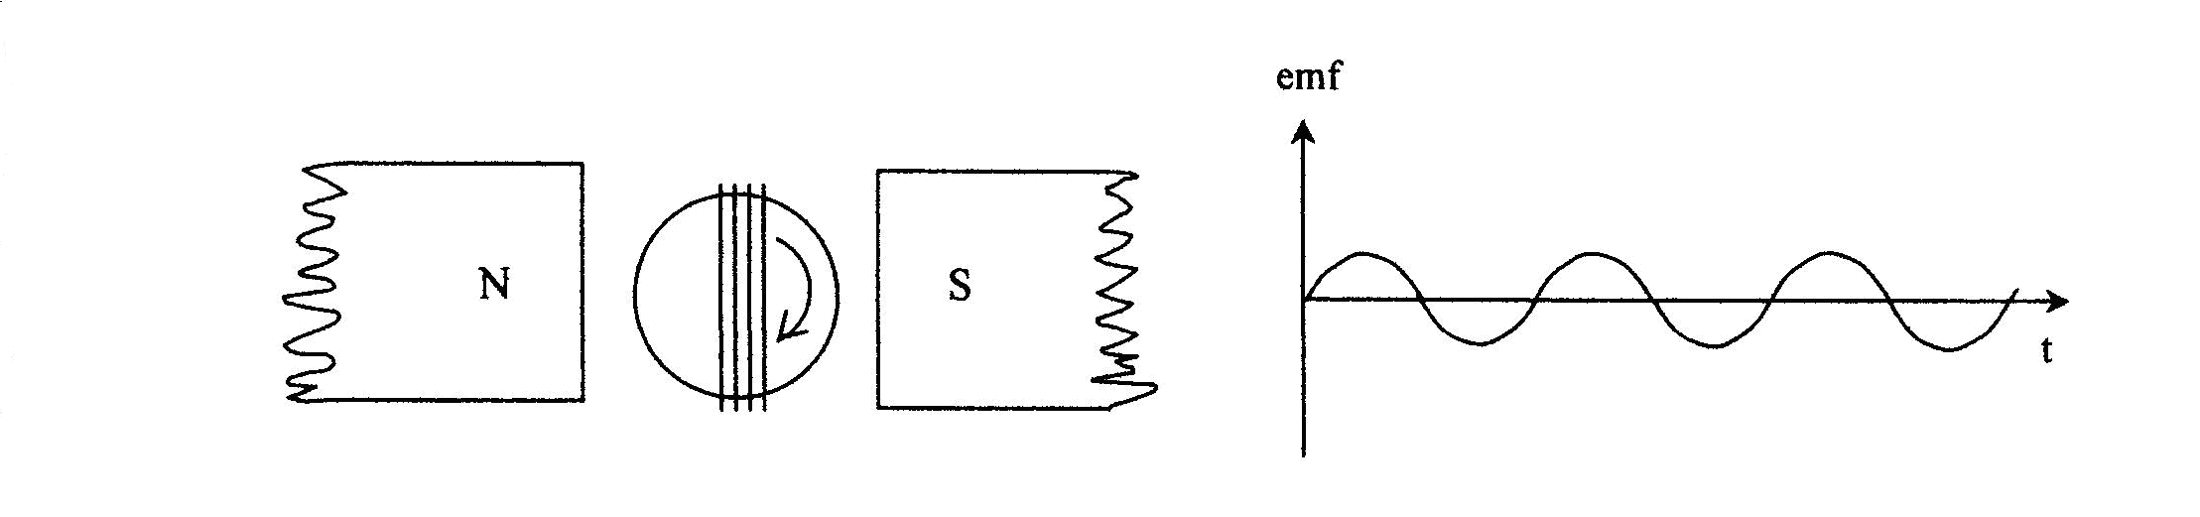

- In each of the following cases, sketch a graph of the output voltage when the changes described are made.

- Next to each state the reason for your answer.

The dotted line represents the voltage before the change has been applied

- the magnitude of the magnetic field is doubled. (2 marks)
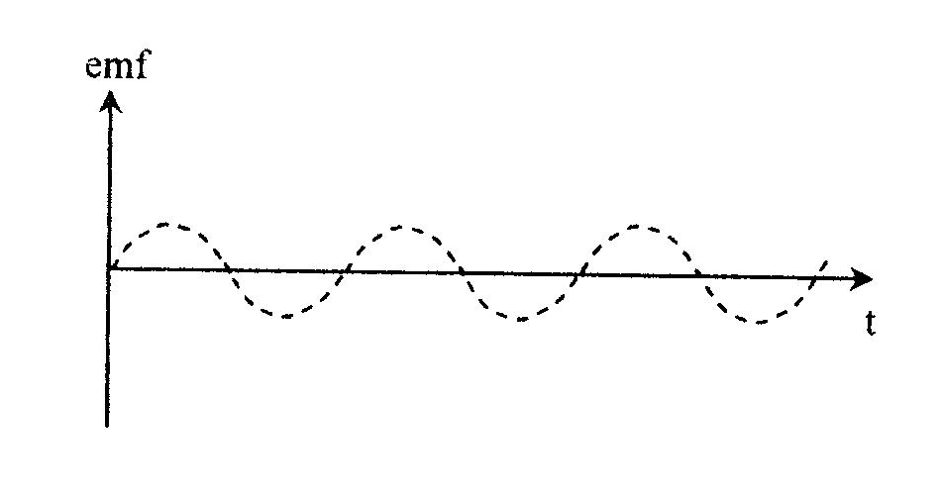

b) the number of turns in the coil is doubled. (2 marks)

c) the rate of rotation of the coil is doubled. (2 marks)

End of Test

